[1]

Social Distance Detector Using Deep Learning

Rupali Deshpande, Harshit Mundhra, Harshita Jain, Vinay Hasani, Pushkar Helge, Samiksha Hiran

Department of Engineering, Sciences and Humanities (DESH)

***Abstract***— COVID19 is a disease caused by the coronavirus, severe respiratory syndrome. The coronavirus is transmitted from person to person primarily through close contact. The document proposes a social distance detection method that uses deep learning to assess the distance between people to mitigate the impact of the coronavirus pandemic. The detection tool is designed to remind people to keep a safe distance from each other by evaluating video sources. Taking the video frame of the camera as input, the open source object detection pre-training model based on the YOLOv3 algorithm is used for pedestrian detection. Later, the video frame is converted into a top-down view to measure the distance from the 2D plane. The distance between people can be estimated. Anyone who does not meet the standard on the screen will be indicated by a red frame and a red line. The proposed method is verified in a pre-recorded video of pedestrians walking on the street.

***Keywords*** *—* Covid19, YOLOv3, Social Distancing, Pedestrian Detection, Deep Learning.

# **INTRODUCTION**

The outbreak of the COVID19 pandemic has brought about the importance of social distancing to intervene in the spread of the virus by slowing down social interaction and maintaining physical distance. Social distancing can be defined as non-drug related Disease prevention and control intervention Mandatory restriction of contact between people infected with the disease and uninfected people, to prevent or reduce the speed and extension of the community. Ultimately, this led to the stop the spread of diseases and a consequent reduction in deaths. The Center for Disease Control and Prevention (CDC) Safety Guide states that the must maintain a distance of at least 6 feet between two people indoors and outdoors.

In Malaysia, the Ministry of Health Malaysia (MOHM) has encouraged numerous disorder prevention measures for workplaces, individuals, and households at home, schools, childcare centers, and senior dwelling facilities. These measures consist of imposing social distancing measures, growing bodily area among people on the workplace, remarkable paintings schedules, lowering social contacts in the workplace, proscribing big paintings-associated gatherings, proscribing non-critical paintings travel, appearing everyday fitness checks of team of workers and traffic getting into buildings, lowering bodily sports particularly for groups which have team of workers in the high-threat category, and carrying out organization occasions or sports online.

Individuals, communities, businesses, and healthcare agencies are all a part of a network with their obligation to mitigate the unfold of the Covid-19 disease. In lowering the effect of this coronavirus pandemic, working towards social distancing and self-isolation have been deemed because the only approaches to interrupt the chain of infections after restarting the financial activities. In fact, it has been located that there are numerous individuals who are ignoring public fitness measures, specifically with appreciate to social distancing. It is comprehensible that given the people’s exhilaration to begin running again, they from time to time have a tendency to overlook or forget the implementation of social distancing. Hence, this project pursuits to facilitate the enforcement of social distancing through imparting computerized detection of social distance violation in places of work and public regions the use of a deep getting to know model. In the location of gadget getting to know and pc vision, there are unique techniques that may be used for item detection. These techniques also can be implemented to hit upon the social distance among people. The following factors summarizes the primary additives of this approach:

1. Deep mastering has received extra interest in object detection become used for human detection purposes.
2. Develop a social distancing detection device that can discover the space among humans to preserve safe.
3. Evaluation of the class consequences via way of means of analyzing real-time video streams from the camera.

# **Literature Review**

This section highlights some of the related done about the human detection using deep learning.In the computer vision task of categorization and localization of its shape in video footage, human detection can be considered an object detection. Deep learning has formed a research trend in multi-class object recognition and detection in artificial intelligence, obtaining excellent results on difficult datasets. Human descriptors, machine learning techniques, occlusion, and real-time detection are all covered in the survey. For visual recognition, techniques using deep convolutional neural network (CNN) are shown to realize superior performance on many image recognition benchmarks.

Deep CNN may be a deep learning algorithm with multilayer perceptron neural networks which contain several convolutional layers, sub-sampling layers, and fully connected layers. Following that, the weights in the network's entire layers are trained for each object classification depending on its dataset.The CNN model, which is supervised feature learning approaches robust in detecting the object in many settings, was one of the categories in deep learning for object detection in images. CNN has achieved great success in large scale image classification tasks due to the recent high performance computing system and large dataset such as ImageNet. Different CNN models for object detection with its object localization had been proposed in terms of specification , algorithms, and new ideas. In recent years, CNN models such as AlexNet, VGG16, InceptionV3, and ResNet-5 are trained to achieve outstanding results in object recognition. Deep learning's effectiveness in object recognition is due to its neural network topology, which can self-construct object descriptors and learn high-level properties that aren't directly presented in the dataset.

The real-time algorithms of object detection using the CNN model such as R-CNN and YOLO had developed to detect multi-classes in a different region in images had been developed.YOLO (You Only Look Once) is the most popular deep CNN-based object detection algorithm in terms of speed and accuracy. The number of individuals in a picture and video with bounding boxes are often detected via these existing deep CNN methods where the YOLO method was employed to detect the video stream taken by the camera. By measuring the Euclidean distance between people, the appliance will highlight whether there's sufficient social distance between people within the video.

# **Methodology/Experimental**

1. **Theory**

In our Social Distance Detector we have used YOLOv3, Object Tracking and Distance Measurement Algorithm. Yolo is a real-time convolutional neural network (CNN) for object detection. It applies CNN to the full image, divides it into regions, predicting bounding boxes and probabilities for each region. These Bounding boxes are weighted by probabilities. Yolo algorithm has many benefits over other algorithms. Benefits of Yolo algorithm are it is extremely fast, Sees the entire image and encodes contextual information about classes as well as their appearance. Another advantage is that when trained on natural photos and tested on artwork, it learns generalizable representations of objects.

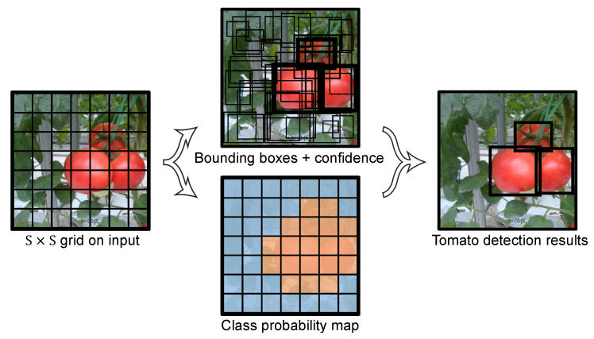

Fig 1: Yolo Algorithm

After detecting initial coordinates, the Object Tracking Algorithm attempts to track an object as it moves about. It is also known as Centroid tracking since it is based on the Euclidean distance between the previous object centroid and the new object centroid between each video frame.

An ideal object tracking algorithm will:

1. Only required the object detection phase once.
2. Faster than running the actual detection itself.
3. Is able to handle when tracked object “disappears” or moves outside of the boundaries of the video frame.
4. Is able to pick up objects it has “lost” in between the video frames.

Process of object tracking algorithm:

1. Takes the initial sets of objects as input.
2. Creates a unique ID for each of the initial detection.
3. Tracking each of the object as they moves around the frames in a video, maintaining the assignment of unique IDs.

Furthermore, object tracking is paramount to building a person counter by assigning a unique Id to each tracked object.

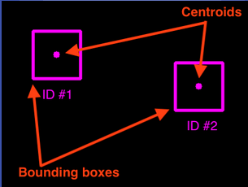

Fig 2: Centroid Detection using Object Tracking Algorithm

1. **Flowchart**

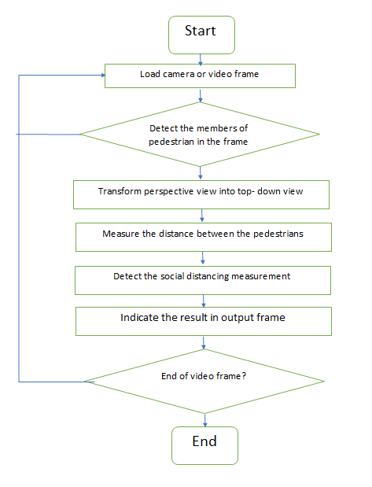

Fig 3: Flowchart of Social Distance Detection Using Deep Learning

# **Results and Discussions**

By using computer vision, a model detecting the social distance between people in the crowded place has been proposed. It basically detect the people who are following social distance and who are not, after detecting it indicated with the green box for the person who follows the social distancing and with the red box for the persons who violates the social distancing. Basically this model is now tested on the recorded video frame of the pedestrians walking on the road.

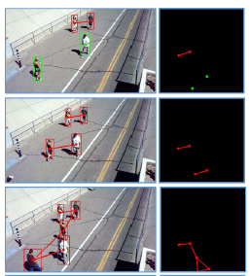

Fig 4: Centroid Tracking And Distance Measurement

# **Limitations**

This model currently works using recorded video frames of walkers strolling along the street, but in the future, it will be able to function immediately with camera input. This model can also be utilized in government buildings, schools, workplaces, restaurants, parks, theatres, temples, and many more populated places in the future. We can also add a siren in the future, which will ring once the social separation is breached. Furthermore, by enhancing the pedestrian detection algorithm, integrating other detection methods such as mask detection and human body temperature detection, increasing the computing capacity of the hardware, and calibrating the camera perspective view, the work are often improved even further.

# **Future Scope**

This model currently works using recorded video frames of walkers strolling along the street, but in the future, it will be able to function immediately with camera input. This model can also be utilized in government buildings, schools, workplaces, restaurants, parks, theatres, temples, and many more populated places in the future. We can also add a siren in the future, which will ring once the social separation is breached. Furthermore, by enhancing the pedestrian detection algorithm, integrating other detection methods such as mask detection and human body temperature detection, increasing the computing capacity of the hardware, and calibrating the camera perspective view, the work are often improved even further.

# **Conclusion**

The results suggest that the proposed method is capable of determining the social distance between individuals in a video. The technology that has been built can be used to create real-time detecting tools. It may possibly be developed in the future so that it can detect whether or not people are wearing masks. This concept is particularly beneficial in public locations where there is a high risk of Covid19 infection, since it can aid in the containment of the deadly virus's spread.

**References**

1. For Yolo Algorithm <https://www.section.io/engineering-education/introduction-to-yolo-algorithm-for-object-detection/>
2. For Object Tracking Algorithm <https://www.pyimagesearch.com/2018/07/23/simple-object-tracking-with-opencv/>
3. For Distance Measurement Algorithm <https://machinelearningmastery.com/distance-measures-for-machine-learning/>

1.